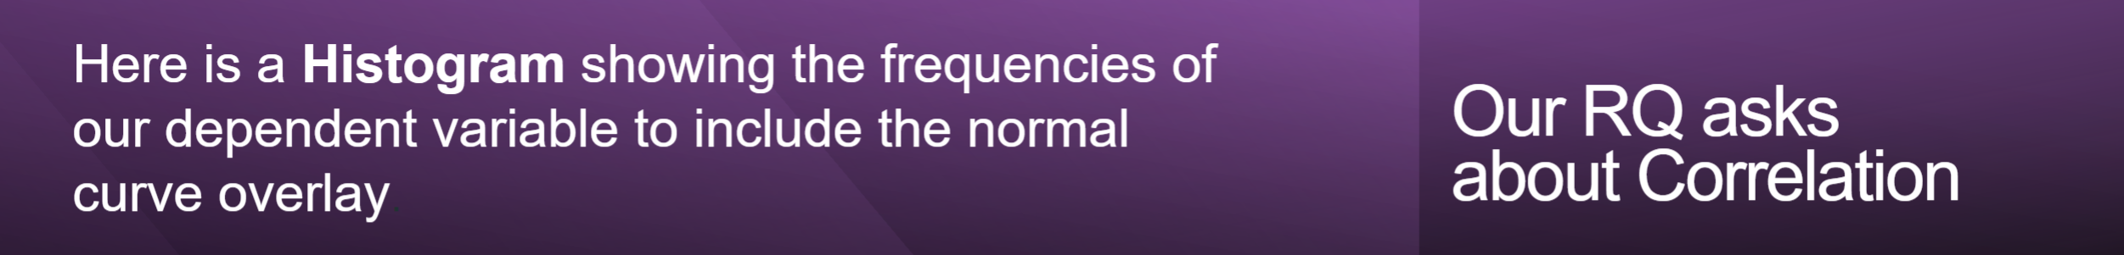

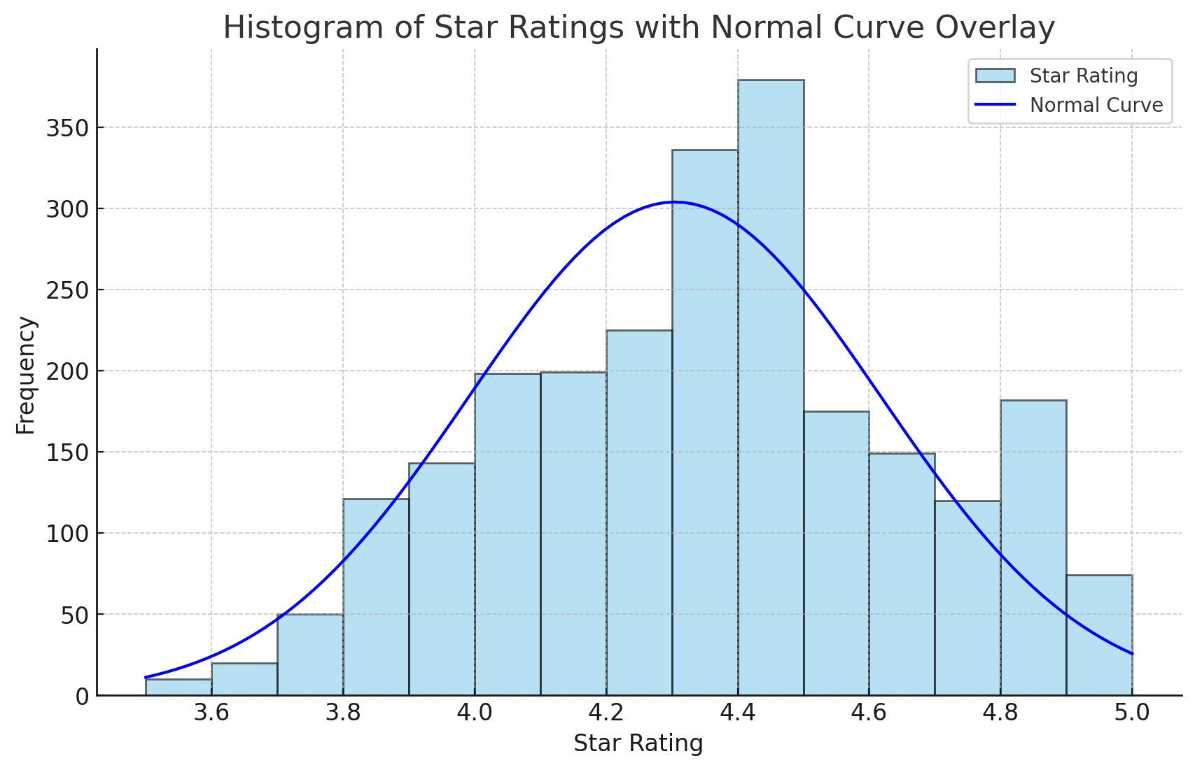

The normal curve overlaid on the histogram does not track the shape of the underlying data closely, and this is expected given that there are clear skew and tail deviations from normality in these distributions. Spearman’s Rho or Kendall’s Tau in view of the fact that these tests do not assume normality and therefore are more appropriate for data that is other than normal

Full marks if all the axes are clearly labelled, with units of measure, and there is a trendline running through the scatterplot (for correlation-type questions). IMPORTANT: The axes must use proper ENGLISH, not the wording from the dataset column if abbreviated, underscored, etc. The dependent variable is on the y axis.

X and Y Axes:
The x-axis is titled Star Rating. The y-axis reads "Frequency," which is correct, Since the task emphasizes direct counts (how many restaurants fall within a specific star rating), labeling the y-axis as "Frequency" makes the chart more intuitive for this analysis.
Title:
It has a title that describes the plot: Histogram of Star Ratings with Normal Curve Overlay.

Normal Bell Curve:
The smooth normal bell curve on top of the histogram

Data Visualisation: For Comparison of Means/Medians and Correlation questions only. Is the Histogram correct?

Yes

Correctness

Dependent variable:
The histogram describes the dependent variable (StarRating) appropriately, as it presents a frequency distribution.

Normal Curve Overlay:
Having a normal curve overlay thus helps you to visually check for the data distribution if its normal or not, which is important in choosing the right statistical test to perform.

Axes and Labels:
Axes are correctly labelled, and the plot has a sensible title fulfilling our third requirement for clear and informative visualization.
Suitability for Analysis: The histogram accurately enables

Comparison of Means/Medians:
This depends on the shape of the distribution, to choose a part between parametric and non-parametric tests.

Correlation assessment:
The difference is the main part, but the distribution of dependent variable cannot be neglected as well.

Data Visualisation: Does response state whether dep variable appears normally distributed or not? (N/A for comp of proportions)?

The distribution of our dependent variable, StarRating, shows a small right skew away from the normal curve. It does not quite fit the bell-shaped curve of a normal distribution. The data does not follow perfect normality. Although the histogram displays near-symmetry, deviations suggest that this distribution does not meet the parametric assumption of normality.

